**Gitlab Installation and configuration guide**

|  |  |  |  |
| --- | --- | --- | --- |
| **Document Name** | **Version** | **Prepared by** | **Reviewed by** |
| GitLab Installation and configuration guide | v.01 | Tarunendra Tripathi | Sumit Malhotra |
|  |  |  |  |

Contents

Introduction 2

Reference URL 2

Dependency 2

Execute below step1 2

Execute below step2 2

List of dependency: 3

To configure external url 3

To take effect of changes 3

Configure port in Gitlab 4

Dev URL with Screenshot 5

UAT URL with screenshot 5

Configure db port 6

Gitlab.rb file configuration 6

Postgres Database Configuration 7

# Introduction

This document contains the installation and configuration of GitLab on RHEL environment.

# Reference URL

Use below url for reference during installation and configuration.

<https://packages.gitlab.com/gitlab/gitlab-ce/packages/el/7/gitlab-ce-11.6.0-ce.0.el7.x86_64.rpm>

<https://dl.fedoraproject.org/pub/epel/7/x86_64/Packages/e/epel-release-7-11.noarch.rpm>

# Dependency

rpm -ivh CurlXXXXXXXXXXXXXXXXXXXXXXXXXXXXXXXX

rpm -ivh OpenSSHXXXXXXXXXXXXXXXXXXXXXXXXXXXXXX

rpm -ivh gitlab XXXXXXXXXXXXXXXXXXXXXXXXXXXXXXXX

## Execute below step1

rpm -ivh curl-7.29.0-57.el7.x86_64.rpm curl-7.73.0-2.fc34.x86_64.rpm

rpm -ivh openssh-8.4p1-2-omv4002.x86_64.rpm

rpm -ivh gitlab-ce-11.6.0-ce.0.el7.x86_64.rpm

## Execute below step2

sudo systemctl enable sshd

sudo systemctl start sshd

# Check if opening the firewall is needed with: sudo systemctl status firewalld

sudo firewall-cmd --permanent --add-service=http

sudo firewall-cmd --permanent --add-service=https

sudo systemctl reload firewalld

# systemctl start postfix

# systemctl enable postfix

# systemctl status postfix

# rpm -ivh gitlab-ce-11.6.0-ce.0.el7.x86_64.rpm

# List of dependency:

rpm -ivh nspr-4.25.0-2.el7_9.x86_64.rpm

rpm -ivh nss-util-3.44.0-4.el7_7.x86_64.rpm

rpm -ivh nss-softokn-3.44.0-8.el7_7.x86_64.rpm

rpm -ivh nss-3.44.0-7.el7_7.x86_64.rpm

rpm -ivh nss-pem-1.0.3-7.el7.x86_64.rpm

rpm -ivh libssh2-1.8.0-3.el7.x86_64.rpm

rpm -ivh libcurl-7.29.0-57.el7.x86_64.rpm

rpm -ivh curl-7.29.0-57.el7.x86_64.rpm

# To configure external url

external_url "http://gitlab.example.com"

# To take effect of changes

sudo gitlab-ctl reconfigure

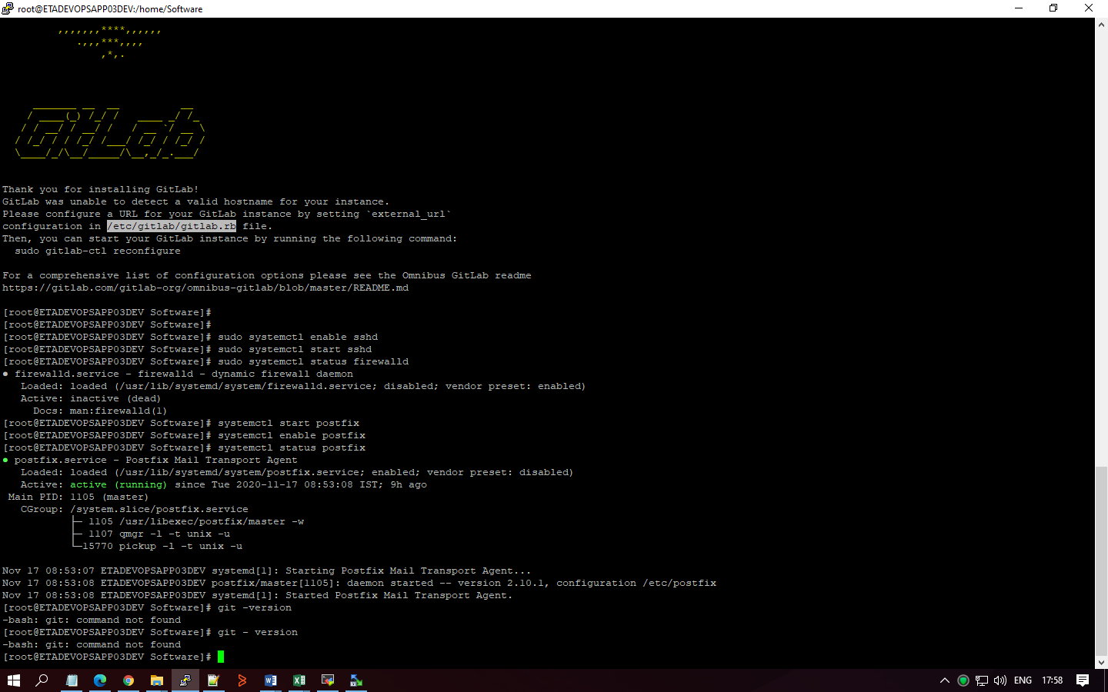

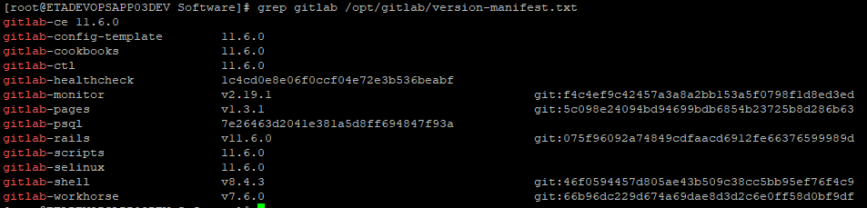

# Configure port in Gitlab

vi /var/opt/gitlab/nginx/conf/gitlab-http.conf

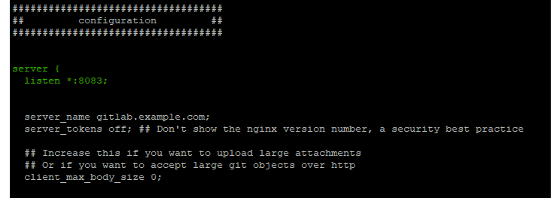

# Dev URL with Screenshot

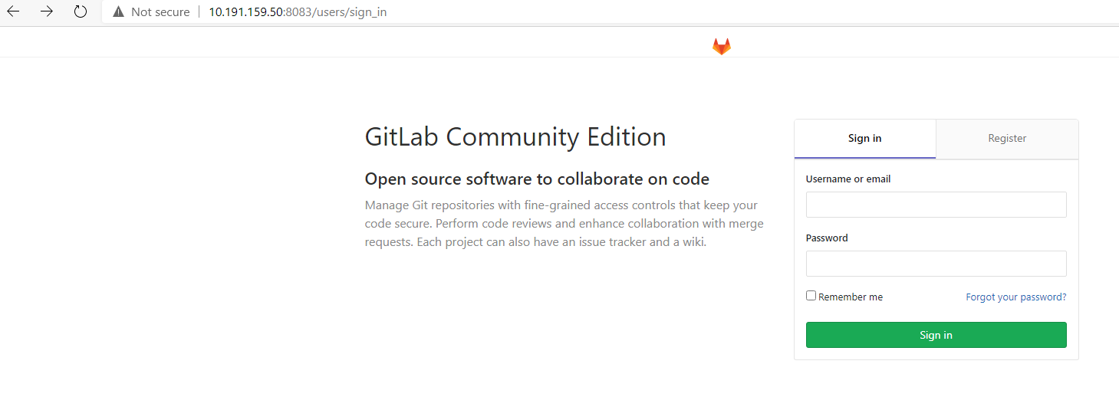

# UAT URL with screenshot

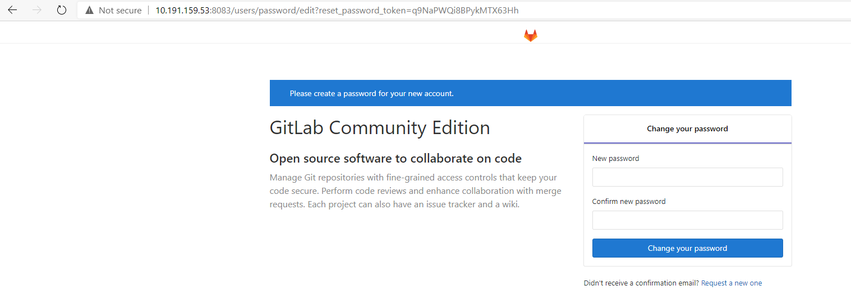

# Configure db port



vi /opt/gitlab/embedded/service/gitlab-rails/config/database.yml

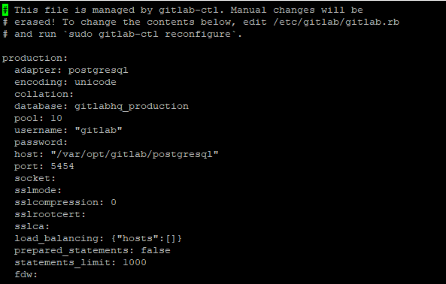

=========================================================================

# Gitlab.rb file configuration

vi /etc/gitlab/gitlab.rb

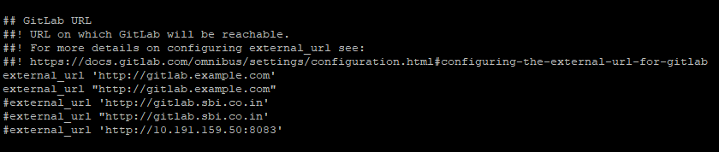

vi /var/opt/gitlab/nginx/conf/gitlab-http.conf

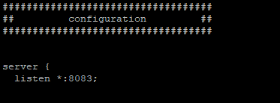

vi /opt/gitlab/embedded/service/gitlab-rails/config/gitlab.yml

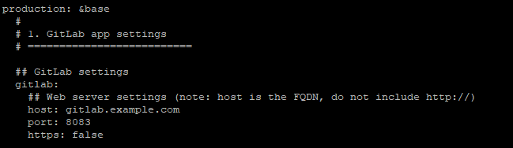

systemctl restart gitlab-runsvdir.service

gitlab-ctl start

sudo gitlab-ctl reconfigure (only if changes into Vi /etc/gitlab/gitlab.rb)

# Postgres Database Configuration

CREATE USER gitlab WITH PASSWORD 'gitlab';

CREATE DATABASE gitlab WITH ENCODING 'UNICODE' LC_COLLATE 'C' LC_CTYPE 'C' TEMPLATE TEMPLATE0;

GRANT CONNECT ON DATABASE gitlab TO gitlab;

GRANT USAGE ON SCHEMA public TO gitlab;

GRANT SELECT, INSERT, UPDATE, DELETE ON ALL TABLES IN SCHEMA public TO gitlab;

GRANT ALL PRIVILEGES ON ALL TABLES IN SCHEMA public TO gitlab;

GRANT ALL PRIVILEGES ON ALL SEQUENCES IN SCHEMA public TO gitlab;

GRANT ALL PRIVILEGES ON DATABASE gitlab TO gitlab;

ALTER USER gitlab CREATEDB;

ALTER USER gitlab WITH SUPERUSER;

ALTER DEFAULT PRIVILEGES FOR USER gitlab IN SCHEMA public GRANT SELECT, INSERT, UPDATE, DELETE ON TABLES TO gitlab;

psql -U gitlab -d gitlab